**Test Case** **0026**

**System:** VirtuCardsClient & VirtuCardsHost

**Description:** Test that the waiting screens reflects the selected game information

**Severity:** 3

**Instructions**

**Test 1**

1. Start VirtuCardClient application
2. Click the button labeled “Sign In”
3. Enter “virtucards01@gmail.com” into the text input labeled “Enter email…”
4. Enter “Testing1” into the text input labeled “Enter password…”
5. Press the button labeled “Login”
6. A window should appear saying “Login Success”
7. Press the OK button that appears on that window
8. Start VirtuCardHost application
9. Repeat steps 2-7 but on the VirtuCardHost application, but use “virtucards02@gmail.com” as the email and use “Testing1” as the password
10. Select the “GoFish” option from the game choices dropdown
11. The checkbox “Allow host to Join” should be checked on the host
12. Press the Create Game button
13. On the VirtuCardClient application enter the 6-character room code found on the host’s screen into the field labeled “Enter Code…”
14. Press the Join Game button on the client
15. Start another VirtuCardClient application
16. Repeat steps 2-7 on the new VirtuCardClient application, but use “virtucards02@gmail.com” as the email and use “Testing1” as the password
17. After both players have joined, press the start game button on the VirtuCardHost application.
18. On the client whose turn it is, click the button available below the “Skip Turn” button that looks like .

**Expected Result:** There is a Hide Cards button available

**VirtuCard Client:**

Client current player game screen

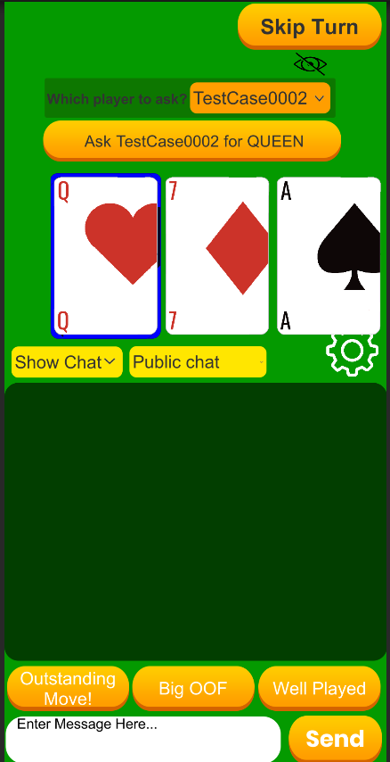

**Test 2**

1. Start VirtuCardClient application
2. Click the button labeled “Sign In”
3. Enter “virtucards01@gmail.com” into the text input labeled “Enter email…”
4. Enter “Testing1” into the text input labeled “Enter password…”
5. Press the button labeled “Login”
6. A window should appear saying “Login Success”
7. Press the OK button that appears on that window
8. Start VirtuCardHost application
9. Repeat steps 2-7 but on the VirtuCardHost application, but use “virtucards02@gmail.com” as the email and use “Testing1” as the password
10. Select the “GoFish” option from the game choices dropdown
11. The checkbox “Allow host to Join” should be checked on the host
12. Press the Create Game button
13. On the VirtuCardClient application enter the 6-character room code found on the host’s screen into the field labeled “Enter Code…”
14. Press the Join Game button on the client
15. Start another VirtuCardClient application
16. Repeat steps 2-7 on the new VirtuCardClient application, but use “virtucards02@gmail.com” as the email and use “Testing1” as the password
17. After both players have joined, press the start game button on the VirtuCardHost application.
18. On the client whose turn it is, click the button available below the “Skip Turn” button that looks like .

**Expected Result:** All the cards on the client should face backward and not display any information about the card. There should also be a rotate animation that flips the card.

**VirtuCard Client:**

Client current player game screen – Cards displayed after a flip animation

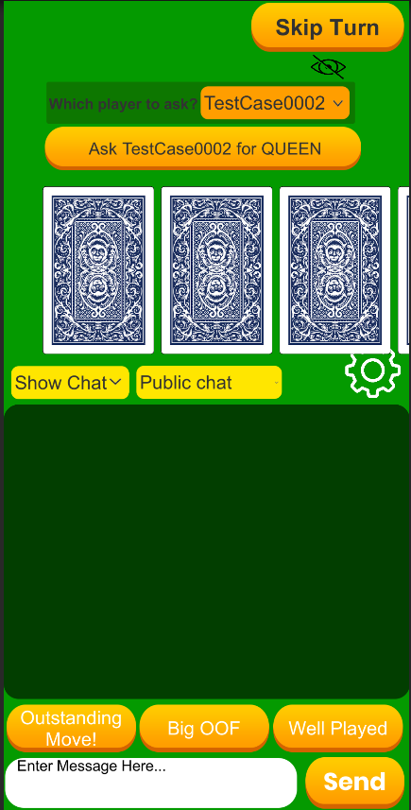

**Test 3**

1. Start VirtuCardClient application
2. Click the button labeled “Sign In”
3. Enter “virtucards01@gmail.com” into the text input labeled “Enter email…”
4. Enter “Testing1” into the text input labeled “Enter password…”
5. Press the button labeled “Login”
6. A window should appear saying “Login Success”
7. Press the OK button that appears on that window
8. Start VirtuCardHost application
9. Repeat steps 2-7 but on the VirtuCardHost application, but use “virtucards02@gmail.com” as the email and use “Testing1” as the password
10. Select the “GoFish” option from the game choices dropdown
11. The checkbox “Allow host to Join” should be checked on the host
12. Press the Create Game button
13. On the VirtuCardClient application enter the 6-character room code found on the host’s screen into the field labeled “Enter Code…”
14. Press the Join Game button on the client
15. Start another VirtuCardClient application
16. Repeat steps 2-7 on the new VirtuCardClient application, but use “virtucards02@gmail.com” as the email and use “Testing1” as the password
17. After both players have joined, press the start game button on the VirtuCardHost application.
18. On the client whose turn it is, click the button available below the “Skip Turn” button that looks like .
19. Repeat step 18, on the client whose turn it is, click the button available below the “Skip Turn” button that looks like .

**Expected Result:** All the cards on the client should face backward initially after first pressing the button. However, after pressing the button again, the previously flipped cards should flip back and the front of the cards should be visible with a rotation animation being played.

**VirtuCard Client:**

Client current player game screen – Cards displayed after an unflip animation

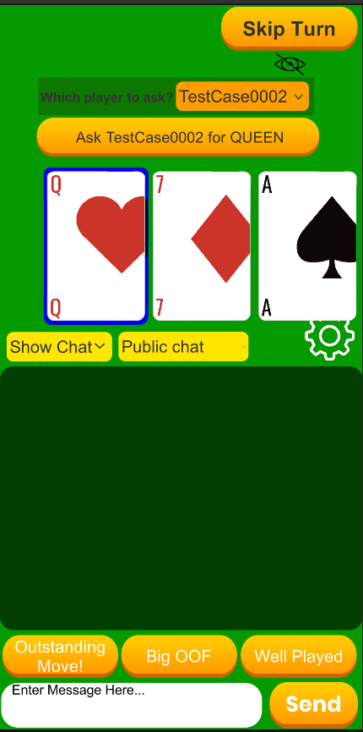

**Test 4**

1. Start VirtuCardClient application
2. Click the button labeled “Sign In”
3. Enter “virtucards01@gmail.com” into the text input labeled “Enter email…”
4. Enter “Testing1” into the text input labeled “Enter password…”
5. Press the button labeled “Login”
6. A window should appear saying “Login Success”
7. Press the OK button that appears on that window
8. Start VirtuCardHost application
9. Repeat steps 2-7 but on the VirtuCardHost application, but use “virtucards02@gmail.com” as the email and use “Testing1” as the password
10. Select the “GoFish” option from the game choices dropdown
11. The checkbox “Allow host to Join” should be checked on the host
12. Press the Create Game button
13. On the VirtuCardClient application enter the 6-character room code found on the host’s screen into the field labeled “Enter Code…”
14. Press the Join Game button on the client
15. Start another VirtuCardClient application
16. Repeat steps 2-7 on the new VirtuCardClient application, but use “virtucards02@gmail.com” as the email and use “Testing1” as the password
17. After both players have joined, press the start game button on the VirtuCardHost application.
18. On the client whose turn it is, move over the cards available.

**Expected Result:** The card that is currently selected should be present with a blue outline around it. The remaining cards should not have the blue outline. When another card is selected, the blue outline is removed from the previously selected card and moves to the newly selected card.

**VirtuCard Client:**

Client current player game screen – Selected card displayed with a blue outline

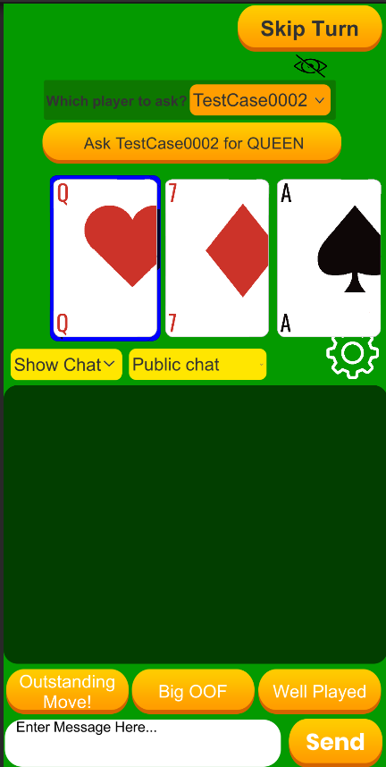

Next card shown with blue outline when selected

